Let's Corp  http://www.letscorp.info | Date: 2020-07-06 15:06:08  P.O. #: PO202007061921

Business Information |  | Shipping Information
Company Name: | VILLARD'S FORMAL WEAR & BRIDAL | Company Name: | VILLARD'S FORMAL WEAR & BRIDAL
Address: | 9401 West Colonial Dr  ste 216  Ocoee, FL 34761  United States | Address: | 9401 West Colonial Dr  ste 216  Ocoee, FL 34761  United States
Contact: | Hugo Villard | Contact: | Hugo Villard
Tel: | 407-535-0495 | Tel: | 407-535-0495
Fax: |  | Fax: | 407-801-5101
E-mail: | thevillards@outlook.com | Address Type: | Commercial
Payment Term: | MasterCard | Shipping Method: | UPS Ground
 |  | Tracking Number: | 1ZE803540351826526
Buyer Comment: | None

Order Detail
Style | Description | Color | Size | Qty | Price | Amount
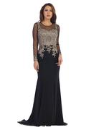  7086M | *** New Style *** | BURGUNDY/GOLD | 3XL | 1 | $79.00 | $79.00
7086M | *** New Style *** | BURGUNDY/GOLD | M | 1 | $79.00 | $79.00
7086M | *** New Style *** | BURGUNDY/GOLD | XL | 1 | $79.00 | $79.00
7086M | *** New Style *** | NAVYGOLD | 2XL | 1 | $79.00 | $79.00
7086M | *** New Style *** | NAVYGOLD | L | 1 | $79.00 | $79.00
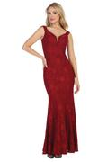  7190 | *** New Style *** | BLUSH | 2XL | 1 | $20.00 | $20.00
7190 | *** New Style *** | BLUSH | 3XL | 1 | $20.00 | $20.00
7190 | *** New Style *** | BURGUNDY | 3XL | 1 | $20.00 | $20.00
7190 | *** New Style *** | NAVY | 3XL | 2 | $20.00 | $40.00
7190 | *** New Style *** | NAVY | L | 1 | $20.00 | $20.00
7190 | *** New Style *** | NAVY | M | 1 | $20.00 | $20.00
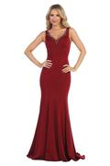  7208 | *** Sale Item *** | BLACK | 2XL | 0 | $20.00 | $0.00
7208 | *** Sale Item *** | DUSTY ROSE | 2XL | 1 | $20.00 | $20.00
7208 | *** Sale Item *** | DUSTY ROSE | 3XL | 1 | $20.00 | $20.00
7208 | *** Sale Item *** | RED | 2XL | 1 | $20.00 | $20.00
7208 | *** Sale Item *** | RED | L | 1 | $20.00 | $20.00
7208 | *** Sale Item *** | RED | M | 1 | $20.00 | $20.00
7208 | *** Sale Item *** | RED | S | 1 | $20.00 | $20.00
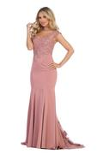  7261 | *** New Style *** | CHAMPAGNE | 3XL | 1 | $78.00 | $78.00
7261 | *** New Style *** | CHAMPAGNE | XL | 1 | $78.00 | $78.00
7261 | *** New Style *** | OFF WHITE | M | 1 | $78.00 | $78.00
7261 | *** New Style *** | OFF WHITE | S | 1 | $78.00 | $78.00
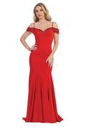  7288 | * SALE ITEM *** | RED | 2XL | 1 | $30.00 | $30.00
7288 | * SALE ITEM *** | RED | 3XL | 1 | $30.00 | $30.00
7288 | * SALE ITEM *** | RED | L | 1 | $30.00 | $30.00
7288 | * SALE ITEM *** | RED | M | 0 | $30.00 | $0.00
7288 | * SALE ITEM *** | RED | XL | 1 | $30.00 | $30.00
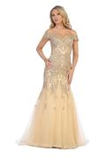  7290 | *** New Style *** | CHAMPAGNE | 2XL | 1 | $126.00 | $126.00
7290 | *** New Style *** | CHAMPAGNE | 3XL | 1 | $126.00 | $126.00
7290 | *** New Style *** | OFFWHITE | 3XL | 1 | $126.00 | $126.00
7290 | *** New Style *** | OFFWHITE | M | 1 | $126.00 | $126.00
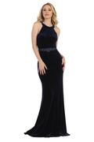  7296 | *** SALE ITEM *** | NAVY | 2XL | 2 | $20.00 | $40.00
7296 | *** SALE ITEM *** | NAVY | 3XL | 2 | $20.00 | $40.00
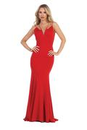  7302 | *** SALE ITEM *** | BURGUNDY | 2XL | 1 | $20.00 | $20.00
7302 | *** SALE ITEM *** | BURGUNDY | 3XL | 1 | $20.00 | $20.00
7302 | *** SALE ITEM *** | BURGUNDY | L | 1 | $20.00 | $20.00
7302 | *** SALE ITEM *** | BURGUNDY | M | 1 | $20.00 | $20.00
7302 | *** SALE ITEM *** | BURGUNDY | XL | 1 | $20.00 | $20.00
7302 | *** SALE ITEM *** | RED | 2XL | 1 | $20.00 | $20.00
7302 | *** SALE ITEM *** | RED | 3XL | 1 | $20.00 | $20.00
7302 | *** SALE ITEM *** | RED | L | 1 | $20.00 | $20.00
7302 | *** SALE ITEM *** | RED | M | 1 | $20.00 | $20.00
7302 | *** SALE ITEM *** | RED | XL | 1 | $20.00 | $20.00
7302 | *** SALE ITEM *** | ROYALBLUE | 2XL | 1 | $20.00 | $20.00
7302 | *** SALE ITEM *** | ROYALBLUE | 3XL | 1 | $20.00 | $20.00
7302 | *** SALE ITEM *** | ROYALBLUE | L | 1 | $20.00 | $20.00
7302 | *** SALE ITEM *** | ROYALBLUE | M | 1 | $20.00 | $20.00
7302 | *** SALE ITEM *** | ROYALBLUE | S | 1 | $20.00 | $20.00
7302 | *** SALE ITEM *** | ROYALBLUE | XL | 1 | $20.00 | $20.00
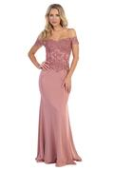  7320 | *** New Style *** | BURGUNDY | S | 1 | $30.00 | $30.00
7320 | *** New Style *** | NAVY | S | 1 | $30.00 | $30.00
7320 | *** New Style *** | NAVY | XS | 1 | $30.00 | $30.00
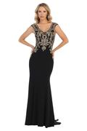  7325 | *** New Style *** | BURGUNDY/GOLD | S | 1 | $50.00 | $50.00
7325 | *** New Style *** | CHAMPAGNE/GOLD | 3XL | 1 | $50.00 | $50.00
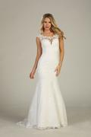  7328 | *** New Style *** | OFFWHITE | XL | 1 | $136.00 | $136.00
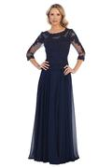  7339M | *** New Style *** | BURGUNDY | 5XL | 1 | $82.00 | $82.00
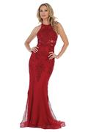  7351 | *** New Style *** | OFFWHITE | XS | 1 | $50.00 | $50.00
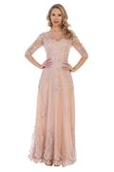  7354M | *** New Style *** | BURGUNDY | 3XL | 1 | $50.00 | $50.00
7354M | *** New Style *** | NAVY | 4XL | 1 | $50.00 | $50.00
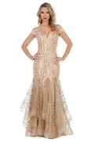  7394 | *** New Style *** | CHAMPAGNE | XL | 1 | $79.00 | $79.00
7394 | *** New Style *** | MAUVE | L | 1 | $79.00 | $79.00
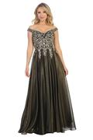  7507L | *** New Style *** | NAVY/GOLD | 2XL | 1 | $40.00 | $40.00
7507L | *** New Style *** | NAVY/GOLD | 3XL | 1 | $40.00 | $40.00
7507L | *** New Style *** | NAVY/GOLD | L | 1 | $40.00 | $40.00
7507L | *** New Style *** | NAVY/GOLD | XL | 1 | $40.00 | $40.00
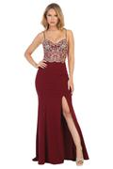  7540L | *** New Style *** | BURGUNDYGOLD | XL | 1 | $76.00 | $76.00
7540L | *** New Style *** | CHAMPAGNE/GOLD | L | 1 | $76.00 | $76.00
7540L | *** New Style *** | RED/GOLD | L | 1 | $76.00 | $76.00
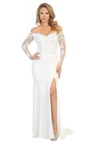  7561L | *** New Style *** | OFFWHITE | M | 1 | $86.00 | $86.00
7561L | *** New Style *** | OFFWHITE | XL | 1 | $86.00 | $86.00
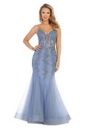  7575L | *** New Style *** | OFFWHITE | L | 1 | $108.00 | $108.00
7575L | *** New Style *** | OFFWHITE | M | 1 | $108.00 | $108.00
7575L | *** New Style *** | OFFWHITE | S | 1 | $108.00 | $108.00
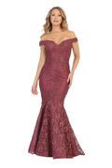  7600L | *** New Style *** | OFF WHITE | 2XL | 1 | $96.00 | $96.00
7600L | *** New Style *** | OFF WHITE | 3XL | 1 | $96.00 | $96.00
7600L | *** New Style *** | OFF WHITE | L | 1 | $96.00 | $96.00
7600L | *** New Style *** | OFF WHITE | M | 1 | $96.00 | $96.00
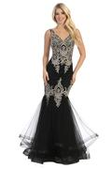  7626L | *** New Style *** | BURGUNDY/GOLD | 3XL | 1 | $76.00 | $76.00
7626L | *** New Style *** | BURGUNDY/GOLD | XL | 1 | $76.00 | $76.00
7626L | *** New Style *** | CHAMPAGNE GOLD | M | 1 | $76.00 | $76.00
7626L | *** New Style *** | CHAMPAGNE GOLD | XL | 1 | $76.00 | $76.00
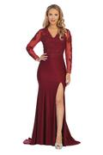  7631L | *** New Style *** | BURGUNDY | 2XL | 1 | $79.00 | $79.00
7631L | *** New Style *** | BURGUNDY | 4XL | 1 | $79.00 | $79.00
7631L | *** New Style *** | BURGUNDY | L | 1 | $79.00 | $79.00
7631L | *** New Style *** | EMERALD | 3XL | 1 | $79.00 | $79.00
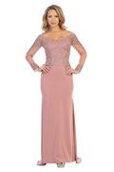  7637L | *** New Style *** | OFF WHITE | 2XL | 1 | $84.00 | $84.00
7637L | *** New Style *** | OFF WHITE | 3XL | 1 | $84.00 | $84.00
7637L | *** New Style *** | OFF WHITE | L | 1 | $84.00 | $84.00
7637L | *** New Style *** | OFF WHITE | M | 1 | $84.00 | $84.00
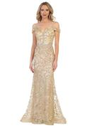  7639L | *** New Style *** | CHAMPAGNE | 2XL | 1 | $72.00 | $72.00
7639L | *** New Style *** | CHAMPAGNE | 3XL | 1 | $72.00 | $72.00
7639L | *** New Style *** | ROSE GOLD | 2XL | 1 | $72.00 | $72.00
7639L | *** New Style *** | ROSE GOLD | L | 1 | $72.00 | $72.00
7639L | *** New Style *** | ROSE GOLD | XL | 1 | $72.00 | $72.00
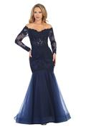  7640L | *** New Style *** | OFF WHITE | 2XL | 1 | $98.00 | $98.00
7640L | *** New Style *** | OFF WHITE | 3XL | 1 | $98.00 | $98.00
7640L | *** New Style *** | OFF WHITE | L | 1 | $98.00 | $98.00
7640L | *** New Style *** | OFF WHITE | XL | 1 | $98.00 | $98.00
(Total Qty: 99 units) Subtotal: |  |  |  |  |  | $5,683.00
Additional Discount: |  |  |  |  |  | - $ 0.00
Shipping Charge: |  |  |  |  |  | $ 558.34
Grand Total: |  |  |  |  |  | $6,241.34

