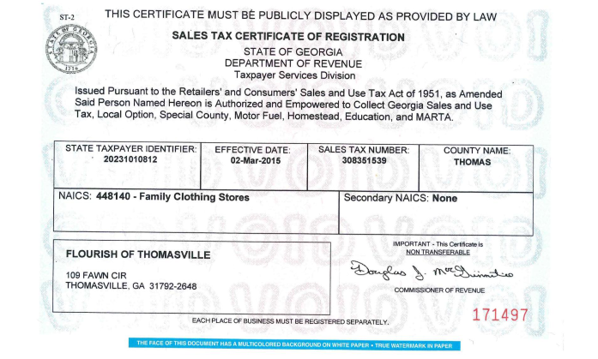
FLOURISH OF THOMASVILLE
FEIN/Tax ID: 47-2044580
Address & Phone | 216 S. Broad Street  Thomasville, GA 31792 | 229.236.5111  229.236.5112 (fax)
E-mail | Gerriann Kennedy, Co-Founder  gkennedy@flourishofthomasville.com | Missy Taylor, Co-Founder  missy@flourishofthomasville.com
Bank Information | Commercial Bank  Attn: Susan Stuckey  susanstuckey@bankcb.com  2704 East Pinetree Blvd.  Thomasville, GA 31792-0710 | 229.236.3662  229.225.9520 (fax)
REFERENCES
Envy Wigs | Attn: Donna Rojas, Sales Consultant  drojas@envywigs.com | 1.877.906.6478 ext 209  305.384.1676 (fax)
Nufoot | Attn: Pat Zweiback Sales Consultant  pat@nufoot.com | 925.743.9831  925.743.9603 (fax)
Total Stockroom | Attn: Rae, Account Manager  11142 Treynorth Dr  Cornelius, NC 28031  rae@totalstockroom.com | 888.789.1037  704.439.1232 (fax)

