Style# | Color | Size | Pic | Price | Our Price
3447 | Eucalyptus  Dusty Rose | XS-4 -XL-12  XS-4-M-8 | 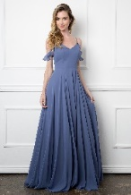 | SO | Shayna
3454 | D. Rose | 5X-22 | 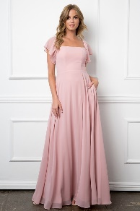 | 49.

